SVC March 30th 2022
Minutes

Subject | Notes
John and Julie outlined the initiatives within their group. | John and Julie were invited to share their experiences from their own group, especially given their successful bidding record.  The group is a constituted body, not a charity.  Initiatives include: Decaff, a walking group, woodland management group, incredible edibles plot, cuppa and a chat, jumble sales. They also funded the new benches down the lines .  Initiatives at GVC are funded through the bidding process and the group has become highly successful in winning bids.  Jumble sales, a popular source of income, were also discussed. However, GCV has a large pool of volunteers, plus a storage area to manage the sales. This is something we can’t currently replicate in SVC.  The GVC is well connected within the council and shared their contacts, who often refer people into their community initiatives.
Key contacts within Bury Council | Tracey Courtman – t.coatman@bury.gov.uk  Austin Wharton – a.wharton@bury.gov.uk  Kathryn Taylor – Kathryn.taylor@bury.gov.uk
Key contacts within VCFA (voluntary group) | Rosemary Lomax  Hamaira Haroon  Sally Deith  Helen Tomlinson  Firstname.lastname@buryvcfa.org.uk
Other useful contacts | Katherine Warburton – Katherine.warburton-gibb@healthwatch.co.uk
SVC Constitution | Emma outlined the proposed changes to the constitution, with a move away from fundraising through events. New focus on bidding for funding.  The group voted in favour of the changes  The group voted in the committee members.  It was also agreed that the group should change its name to Bee Involved In The Community. There is the obvious connection to the bee keeping activity the village is becoming known for, but also an emphasis on inclusivity. The group is need of more regular volunteers.
Summerseat House | Owned by the council  There are no proposed plans for the renovation or use of the property  Still for sale, no potential buyers  Estimated £1M needed to make the building habitable again.  There has been a dispute over the bordering land near Robin Road which prevents access to the site  The council have indicated that they would like any buyer of the property to offer a community angle to its purpose. The ideal would be for it to be a community centre, but it would require a team to run it.
Bee Involved in The Community | It was agreed that the group should change its name and rebrand to Bee Involved In The Community. There is the obvious connection to the bee keeping activity the village is becoming known for, but also an emphasis on inclusivity. The group is need of more regular volunteers.
Bee Keeping | The bee keeping activity continues to be a successful activity in Summerseat, especially with involvement with local schools.  The hives centre on the island is now kitted out with suits.  A £10k bid is being submitted to the Heritage lottery fund, plus a further bid for ‘Honey House’ which offers outreach with schools.
Village community | The cricket club and The Hamers continue to be excellent central hubs for the community and we’re fortunate to have the continuing support of both venues.
The new park | 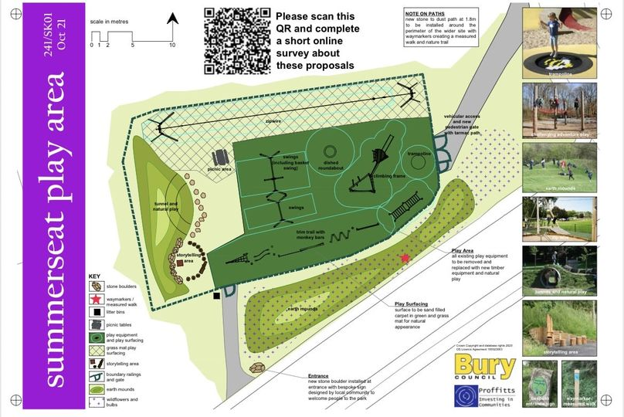  The bid for £150k has been submitted.  The new park plan was shown to the group. It shows the proposed new layout and the theme, which has a more natural feel and blends in with our surroundings.  A decision on the bid will be made by March 2022  It is understood that there have been some concerns from residents about parking around the area.  There was also concern expressed about the park affecting the football pitch area, but the plan demonstrates that the pitch won’t be affected.
Traffic | The council is currently consulting with residents on traffic problems within the village, mainly around the new bridge area.  Issues are around the speed of traffic, parking and the bus.  A give way sign at the end of Cragg Lane was also suggested.
Crime | The committee is arranging a meeting with the community policing team to discuss challenges within the village. However, Summerseat is considered to be a low-crime area in the borough.  A discussion was had around the possibility of forming a neighbourhood watch group, and we’ll be looking into this further. We hope the council will support this initiative.
Support for young people | The Sunnywood project was discussed. This is a community group with offers engagement with young people, teaches them new skills and encourages them to be part of their community. The project is run by Mark Young in Greenmount and has proven to be a success.  To replicate Mark’s project however, requires trained youth workers.
Garden Centre | A request was made for a staff member at the garden centre to help with the vegetable beds at the school.
Plant Barrels | More volunteers are needed to help with the maintenance of the barrels (20 in total) near Al Bosco, on Railway Street and Ruby Street. Wendy would be happy to help on Railway Street and Chris with the ones near Al Bosco. More help needed please!
Herbie | We shall be decorating Herbie on Saturday 11th December at 1pm. Everybody welcome. Back then on the field at 6pm for mulled wine, hot dogs, mince pies, good old sing along and the switch on. Then up to the Hamers Arms at 7pm for pie supper, games and fun. All welcome.
General | It was suggested that more rubbish bins should be available around the village, however at the moment we don’t have the capacity to empty them.

